Ely Walk & Search 2025 Instructions
This walking quiz is based on the Londinium Pedo which is a 6-leg circular walking quiz around a small segment of the City of London. This is just two legs which start and return to a central location in Cherry Hill – the start and finish points are the green area inside the Porta. Teams of two are recommended, if you use more and want to let me know how many, it would help me refine the next one
You do not have to enter any private property to complete the quiz, but you may have to look high & low for the answers, and one or two will test your searching skills. The text and clue numbers are in a specific order, which should narrow down the area where you should be looking for answers. All answers are on permanent structures or items that I’ve been assured will not be moving.
The time limit for each leg is 40 minutes. Go on, be honest with yourselves.
Spending a long time searching for one answer might cost you more points that you gain, so balance that accordingly.
You should take care when crossing roads, crossing points have been highlighted – please use them.
There are toilets just off Market Square, on Palace Green, in Ship Lane Car Park, and in the various pubs you will pass (ask nicely first, please).
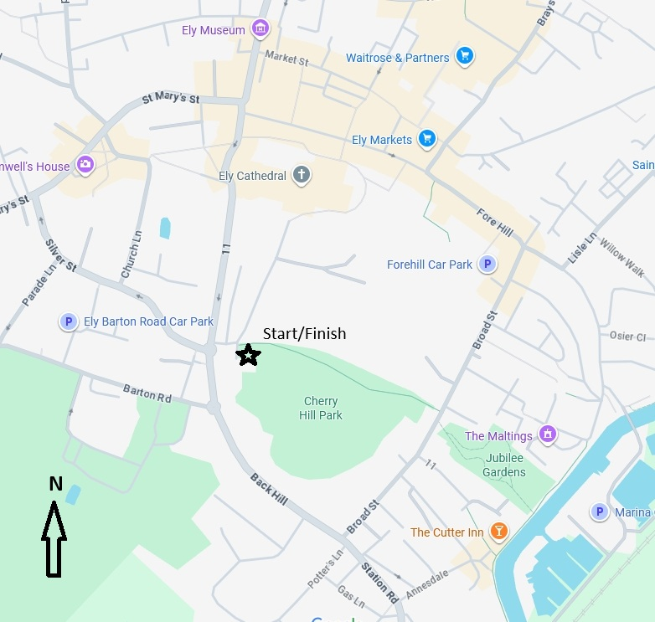

If you want to find out how you did contact me at clivekingsmeadow@outlook.com and I’ll send you a complete answer sheet with a little more about the places en route.
If you enjoyed this quiz and want to buy me a coffee, send a £ to @clivealive99 on PayPal, many thanks.
Ely Walk & Search 2025 2 pts per correct answer, -1 pt per minute late
Competitor | Search Score | Time Penalty | Total part A | No. in team
Part A: Your start time_____________ Expected finish time ________________ Actual Time ____________
Exit westwards through the Porta, bear left and cross over carefully into the triangular green of Barton Square (Q1). Don’t stray so far though, and at The Fountain pub on the corner, turn left into Silver Street.
The 15th century buildings on the left are worth a visit on open days as they contain some aged wall paintings. Enjoy the glimpses of the West Tower over your right shoulder as you continue (Q2) until you reach the pub (Q3). Retrace your steps to the signpost and head towards Oliver Cromwell’s House down Church Lane. Pass what was once The Malt and Hops, and after (Q4) you will be rewarded with a grand view of the front of Ely Cathedral.
Follow Church Lane round to the left, between The Old Fire Engine House, now a fine restaurant, and St Mary’s Church. Use the crossing on the far side of the grassy area, opposite Poets House, and turn to your right towards town (Q5) passing the Bake Shop and heading towards St Mary’s Car Park (Q6). Safely negotiate the entrance/exit to the car park, then continue past the Kings Arms to an assortment of shops (Q7). The Lamb Hotel stands beyond the traffic lights, the oldest surviving inn in Ely, dating from 1416. Turn the corner at The Sweet Shop and cross towards the Lamb at the crossing, turning and being careful along the narrow pavement.
Turn right into Market St, the old jail on the far side is now part of Ely Museum full of interesting information about Ely and the Fens. Continue down Market Street, past The Herward (Q8) and Rumbles Fish Bar. Continue straight into the pedestrianised area (Q9) which leads to Market Place where stallholders gather several times a week. At its centre (if there isn’t a market covering it) is a sundial laid into the flagstones. There’s a mix of old and new surrounding Market Place itself (Q10), including a large Woodgreen charity shop next to which is the narrow Buttermarket (Q11) which joins Dolphin Lane – named after the Dolphin Inn which stood on the corner. Continue onto the High Street with its old Cathedral buildings on the left and more modern shops on the right.
Keep going past the Sacrist’s Gate, 1325-6, on your left, and the slightly more-tempting Tom’s cakes on your right, and towards a collection of charity outlets (Q12) and the excellent Toppings Book Shop until you reach the doors of the Lamb again (Q13) after you have had a blooming good search, carefully cross the High Street to head past the Minster Tavern and past front of the Cathedral. Follow this road, which becomes The Gallery back to the Porta (Q14) and return to the checkpoint.
Q1 | Five are seated here, since when? |  |  | Q8 | Where can you go, EVERY DAY?
Q2 | Who is fondly remembered? |  |  | Q9 | When was ED here?
Q3 | _ _ 1869 |  |  | Q10 | What suit can you see?
Q4 | What grade did Clarksteel get? |  |  | Q11 | What did Fisher & Co make?
Q5 | GBTE, but which year? |  |  | Q12 | Mind the Gap at which London underground station?
Q6 | Who restored here? |  |  | Q13 | 01335 _ _ _ _ _ _
Q7 | Formerly whose? |  |  | Q14 | How high is the door?

Ely Walk & Search 2025 2 pts per correct answer, -1 pt per minute late
Competitor | Search Score | Time Penalty | Total part B | No. in team

Part B: Your start time_____________ Expected finish time ________________ Actual Time ____________
Head down Cherry Hill, which once used to have a Norman Castle on it and is named after Ely’s once-famous Cherry Orchards. On towards the river and exit on to the busy Broad Street through the archway (Q1) there’s a crossing just to your right, use it and continue South along Broad Street (Q2).
Pass the soaring Eagle on your right and turn left at the end of the road into Station Road, keep to the left and it becomes Castlehythe which oddly turns into Castelhythe at the other end (Q3). Take the left into Annesdale and head towards (Q4) the river and the Cutter Inn, named after the cutters who dug the “New Cut” up to Littleport. Walk past it along the riverbank path (Q5) and marvel at the wet rock at the east end of Jubilee Park where many fairs are held.
Lots of holiday boats more up along this stretch (Q6) and the Liberty Belle sets off here for river cruises. The Maltings was built in 1868 and The Ship Inn used to stand in the green area beside it since 1661 but was demolished by 1961 (Q7).
Across the river is the “Isle of Babylon”, cut off from Ely when the river was diverted around 1100, it became a park and is now almost entirely a marina (Q8). Take a look at the quirkily-thin house on your left, perhaps enjoy an Ice cream from the van, and walk left past the antiques centre (Q9) and continue up the curving Waterside (Q10) pausing to enjoy the post-box topper and cross safely into Fore Hill. The pillars and gates of the Old Brewery are on the right at the foot of the hill, very tempting to nip in to the Drayman’s Son for a 1/3 of something refreshing, but you are headed up the hill (Q11) to the Market Square.
If you think you have time, follow the pavement round and stay right to find a vineyard (Q12), now retrace your steps cross the market square to the War Memorial enter the Almonry Door just next to it, go through the arch ahead of you, and then right into the Cathedral Garden (Q13) and head left of the Cathedral on the curved path past 7 stone graves, are you out of time yet? (Q14). Head away from the Cathedral’s south door back towards the checkpoint.
Q1 | What’s missin in Broad St? |  |  | Q8 | Whose bridge stretches to Babylon?
Q2 | How many Blackbirds are there? |  |  | Q9 | A triplet from F______.com
Q3 | Henley House used to overlook a pub of what name? |  |  | Q10 | What happened on this site in 1782?
Q4 | What did HCH create here? |  |  | Q11 | How many City Studios?
Q5 | Who was “Simply the Best”? |  |  | Q12 | Don’t walk far for which wine variety?
Q6 | What might you find between two horses and a fish? |  |  | Q13 | Helps with Bones and Joints L____, N _____, C______
Q7 | Elizabeth-Jane _____ |  |  | Q14 | K _ _ _ _ N

